1. **Install OpenSSH or Mobaxterm**
2. **Create EC2 and Connect to it**
3. **Read DevOps LifeCycle and KPIs**
4. **Install OpenSSH or Mobaxterm**

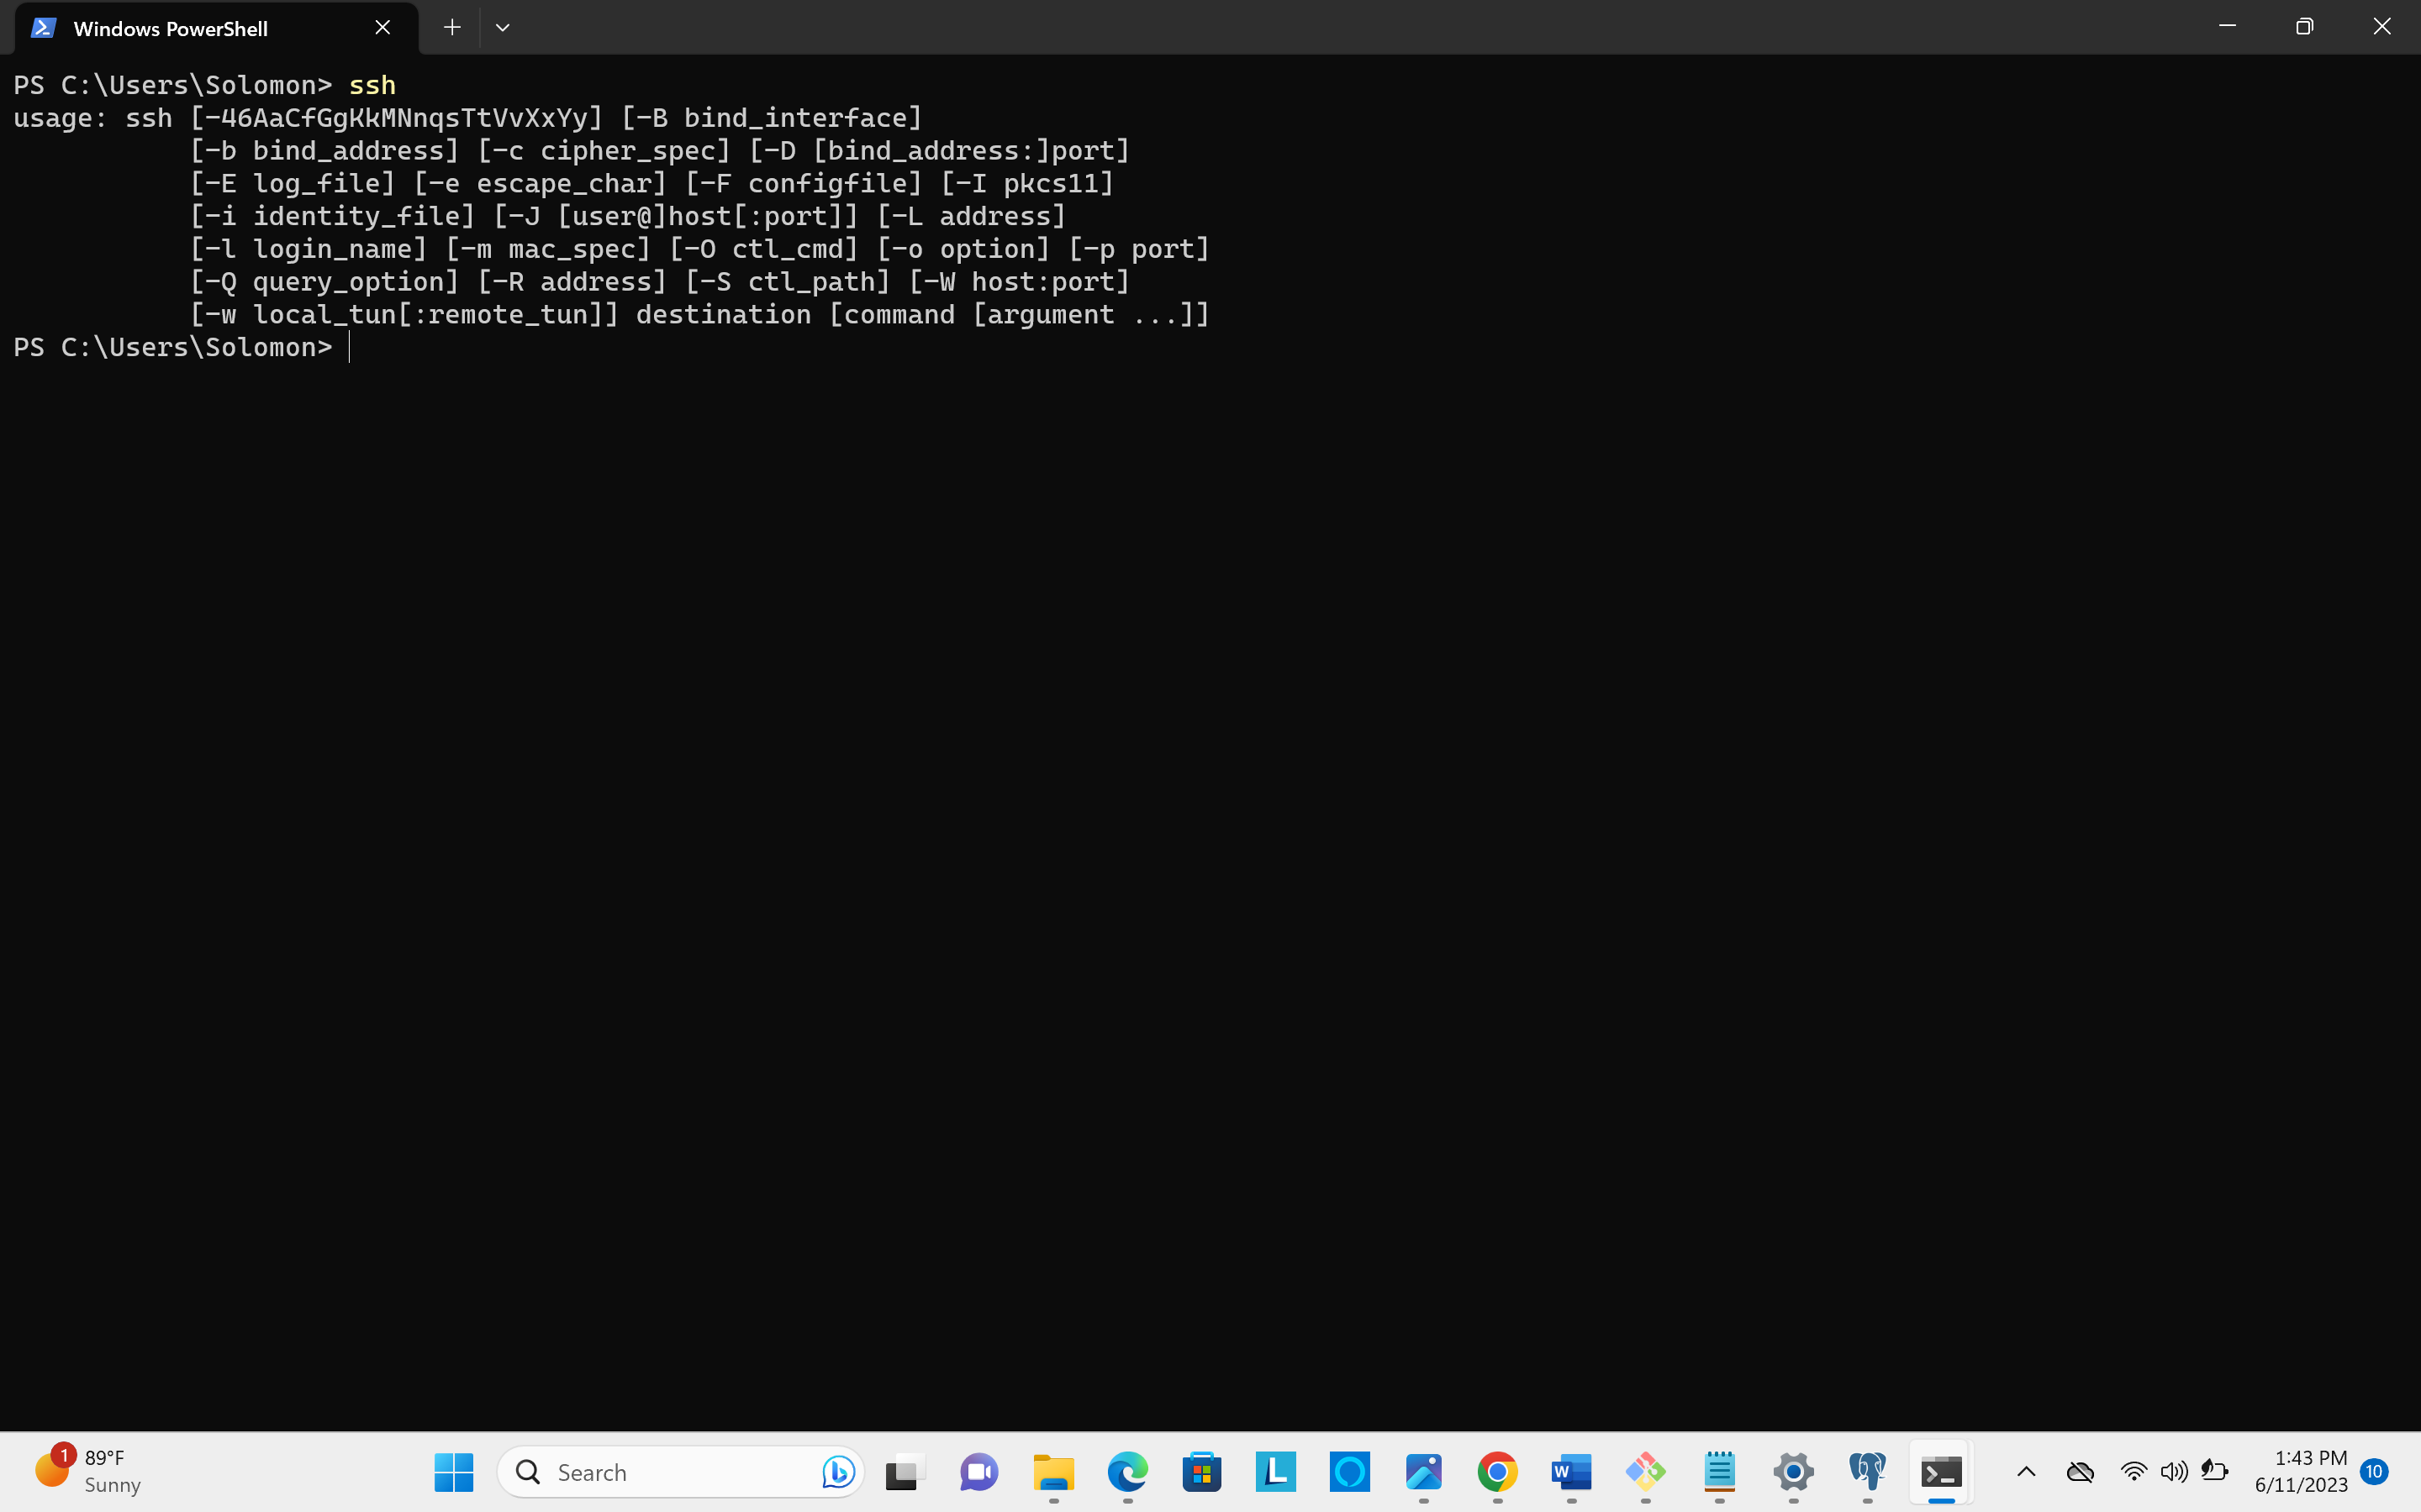

1. **Create EC2 and Connect to it**

